SPICYUP RESTAURANT WEBSITE DOCUMENTATION

1. INTRODUCTION
   1. OVERVIEW:

“SPICYUP Restaurant”management website is a web,tablet and mobile application. This system is developed to automate day to day activity of a restaurant. Restaurant is a kind of business that serves people all over world with ready-made food. This system is developed to provide service facility to restaurant and also to the customer. This restaurant management system can be used by employees in a restaurant to handle the clients, their orders and can help them easily find free tables or place orders.

* 1. PURPOSE:

The main point of developing this website is to help restaurant administrator manage the restaurant business and help customer for online ordering and reserve table. In proposed system user can search for a menu according to his choice i.e. according to price range and category of food and later he can order a meal.

 The services that are provided is food ordering and reservation table management by the customer through the system online, customer information management and waiter information management, menu information management and report. The restaurant menu is organized by categories (appetizers, soups, salads, entrees, sides and drinks) of menu items. Main objective to build the website is to provide ordering and reservation service by online to the customer. Each menu item has a name, price and associated recipe. A recipe for a menu item has a chef, preparation instruction sand associated ingredients. With this website online, ordering and reservation management will become easier and systematic to replace traditional system where are still using paper.

1. LITERATURE SURVEY
   1. Existing Problem:

Today people are busy with their schedule and find difficulties to visit restaurants whenever they need. The difficulties they face like are no tables ready to sit,slow service, taste…,etc.

* 1. Proposed Solution:

The best solution is to above all problems is our restaurant website i.e by making just a call from your location you can preorder the table, items you want in advance. This makes improvement of service rate and also you can visit at your convienient time and have your likes in a less time . This online management also reduce the system of paper booking which is time consuming.

3. FLOW CHART

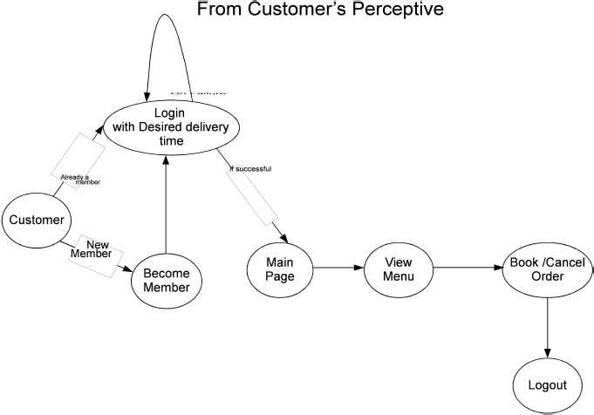

4.ADVANTAGES AND DISADVANTAGES

Advantages

* Sometimes it happens that the tables get booked soon during festive seasons therefore user can make advance booking using this system.
* It saves user’s time looking out for restaurants.
* It saves business’s resources and expenses.

Disadvantages

* Requires an active internet connection.
* It will provide inaccurate results if data not entered properly.
* The system limits human interaction

5.CONCLUSION

The website has concluded that if a customer is willing to visit the restaurant and he finds no table is available for the dinner/lunch then he/she has to wait long for the table availability. With the help of this app user can choice the table‟s location according to their need and willing e.g. Table can be reserved as according to number of visitors. Moreover, you can easily book the hall for a celebration party or any mega event and can see pictures of interior from the website. Keeping in view the demand of proposed project that gives a series of services and provides the customer to easily book hall or to reserve their available table without waiting through a website.

6.FUTURE SCOPE

The future scope of this type of website grows a enormous change because the coming days customers need things to be happened in advance and also in fast process.